Joel Atkinson
February 12, 2026
CSD380 DevOps
Assignment 5.2
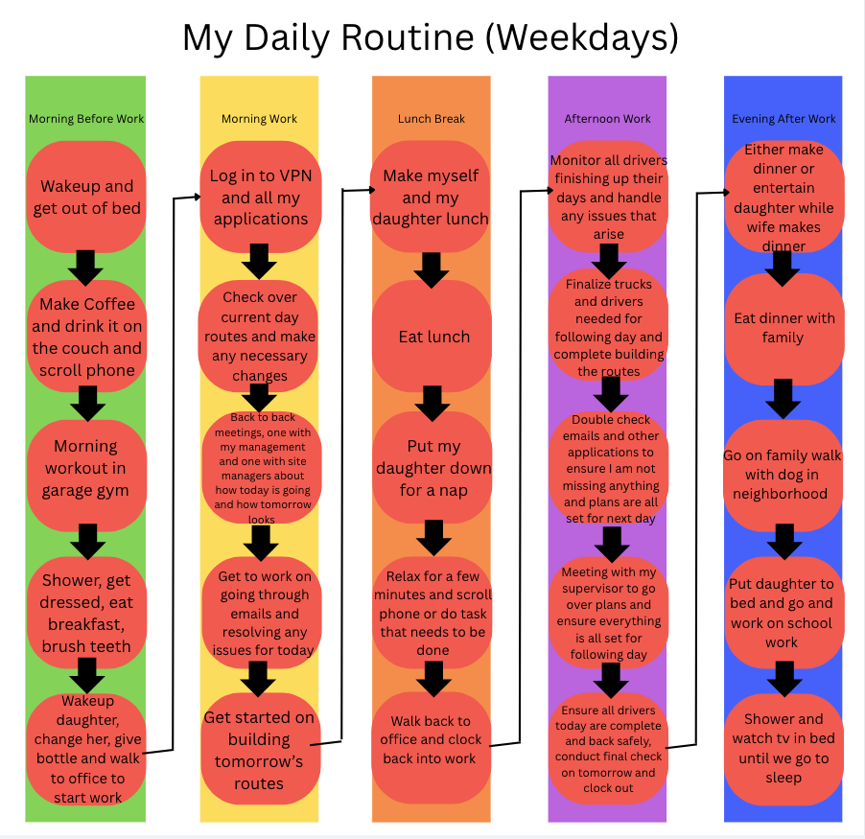
Value Flow Chart:

Analyze Lean Metrics:
Estimated Average Time Flow:
Morning Before Work | 3 Hours
Morning Work | 4 Hours
Lunch Break | 30 Minutes
Afternoon Work | 4 Hours
Evening After Work | 4 Hours

Estimated Cycle Time: 15.5 Hours
After calculating my estimated cycle time of 15.5 hours, I evaluated where the largest concentrations of time exist. Morning and afternoon work account for the majority of structured time, while evening activities represent flexible but potentially inefficient time. The largest opportunities for optimization appear in early morning and evening routines where non-value-added activities such as phone scrolling and excessive television viewing occur. By targeting these stages, I can reduce waste without disrupting high value work activities. This leaves 8-8.5 hours for sleep each day. By optimizing even 30-60 minutes per day, I would be able to significantly increase the time I have available for school, family time, or rest throughout the week

Optimize My Process:
The goal is to ensure I get all of my work, school, and tasks done while still leaving time to spend with my family or to relax.

Eliminating Waste:
I can eliminate time scrolling on my phone in the morning and use that time to instead work on school work. Additionally, I can minimize the time it takes to make breakfast, lunch, and dinner by having a plan set up of what both I and my daughter will have and pre cooking as much as I can on the weekends to be reheated throughout the week. I could also cut back on the amount of time watching tv at night, and even ensure short showers to allow for more time to do school or other tasks at night after work.

Workflow Orchestration:
If I have down times at work, I can take that time to also work on school by having a second monitor set up in my office to work on school during low points of work from the same desk. Additionally, I could skip the scrolling the phone and having coffee in the morning first thing and move that to after my workout and consolidate eating breakfast with drinking coffee and scrolling phone all into one.

Governance Models:
Governance in this context means creating rules around how time is protected and allocated. Without intentional controls, improvements may collapse back into old habits. Some things that restrict this are the requirements that when I am with my daughter for tasks or meals I must be paying attention to what is going on as she is only 1, this limits the amount of multitasking that can be done at those times. Some things I can do to put governance on my time and help me better streamline my workflow are turning off personal notifications to prevent from distractions while working on work or school, this will allow me to better focus and get these things done in a shorter period of time. Additionally, I can ensure that everything is done for the day and set up for tomorrow before I relax.

